

Deliverable-2

Scope, Use case, Business Rule, EERD, Schema



**Scope:**

As per World Health Organization 300, million individuals around the globe have despondency. The issue creating misery these days is legitimately connected to our eating regimen. While diet is associated with psychological well-being, more research is being done on the job that gut plays in emotional wellness. One ought to have an appropriate adjusted eating routine to maintain a strategic distance from physical just as mental issues.These days online Food conveyance markets are on climb, permitting clients to have their preferred nourishment with a solitary tap of their cell phone.

Food ordering application can deal Food item, favored brands, kitchen needs, basic cafe supplies and the sky is the limit from there, through this on the web, one stop Food store. It furnishes you with a helpful method to deal from your Food shopping application. You can utilize this application as one major general store application to deal result of your store. This application make simple for client to purchase item from store with simple advances and store can get simple request.

**Scope to be fulfilled by Client:**

Underneath recorded is a rundown of necessities to be satisfied by the customer

* Our extension approvement
* Content and picture to be included the application.
* Client side testing gadgets
* Payment Gateway Credentials
* More detailed necessities with clarifying the arrangement and current framework what's more, finished extent of the arrangement, For this please lead a gathering at customer side

**Use case:**

Food Ordering System Use Case Diagram. This Use Case Diagram is a realistic delineation of the associations among the components of Food Ordering System. It speaks to the strategy utilized in framework examination to recognize, explain, and compose framework necessities of Food Ordering System.

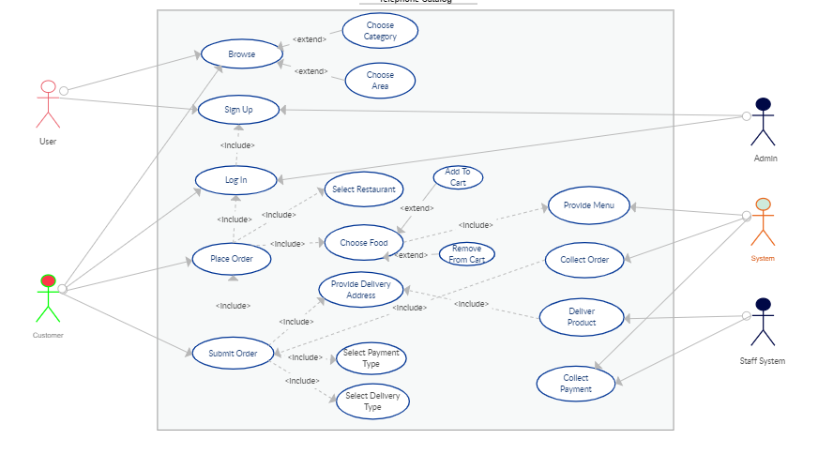

**Business Rule:**

The six Business Rules are

## Social Proof

## Authority

## Scarcity

## Affinity (or, Liking)

## Consistency

## Reciprocity

## Social Proof:

Rule: Follow the Crowd

When confronting vulnerability while web based shopping, purchasers regularly seek different customers for conclusion — they look to what others are doing or have done, and accept the way things are. When something stands apart as well known, we consider it to be social verification, that it is the best accessible alternative or most right decision, basically in light of the fact that every other person apparently is picking it.

## Authority:

Rule: Follow the Authority

Much the same as customers trust each other when web based shopping; they additionally trust experts and specialists. Like social evidence, the impression of power that specialists and even famous people have can show customers that a contribution is significant or the most right decision — more often than not it just settles on the purchaser's choice for them.

## Scarcity:

Rule: Scarce Stuff is Good Stuff

At the point when a shopper feels that there is little of something that they need, they are bound to buy the contribution. Casually, this can be considered as the "dread of passing up a major opportunity", or FOMO. Advertisers can utilize FOMO furthering their potential benefit when attempting to pull in shoppers to specific contributions.

## Affinity (or, Liking):

Rule: Follow those You Like

Buyers tend to follow individuals that they like, identify with, or respect — it manufactures social bonds and trust. It's similar to the old secondary school social framework, where you would attempt to be comfortable with or get into something that your pulverize preferred; I realize I did!

## Consistency:

Rule: Be Consistent

At the point when confronted with vulnerability, shoppers are probably going to go with what they know and settle on a choice dependent on past choices, convictions, and practices. We can feel mental distress, or "subjective disharmony" when our convictions and practices don't coordinate, which is a key helper towards predictable dynamic. Propensities are likewise included, as certain customers dread change or simply like adhering to the equivalent online news/climate website, and so on.

## Reciprocity:

Rule: Repay favours

We feel great when we reimburse favors, it is simply human. Doing useful for somebody who has done bravo is satisfying, as us, all would know. As far as web based shopping, advertisers can utilize this to further their potential benefit as they can, in any structure, total a Cavour for the customer and expectation that the buyer reimburses the kindness.

**EERD:**

Enhanced entity-relationship (EER) diagrams outlines are essentially a developed rendition of ER diagram. EER models are useful instruments for planning databases with significant level models. With their upgraded highlights, you can design databases even more altogether by diving into the properties and requirements with more accuracy. The EERD of our project is

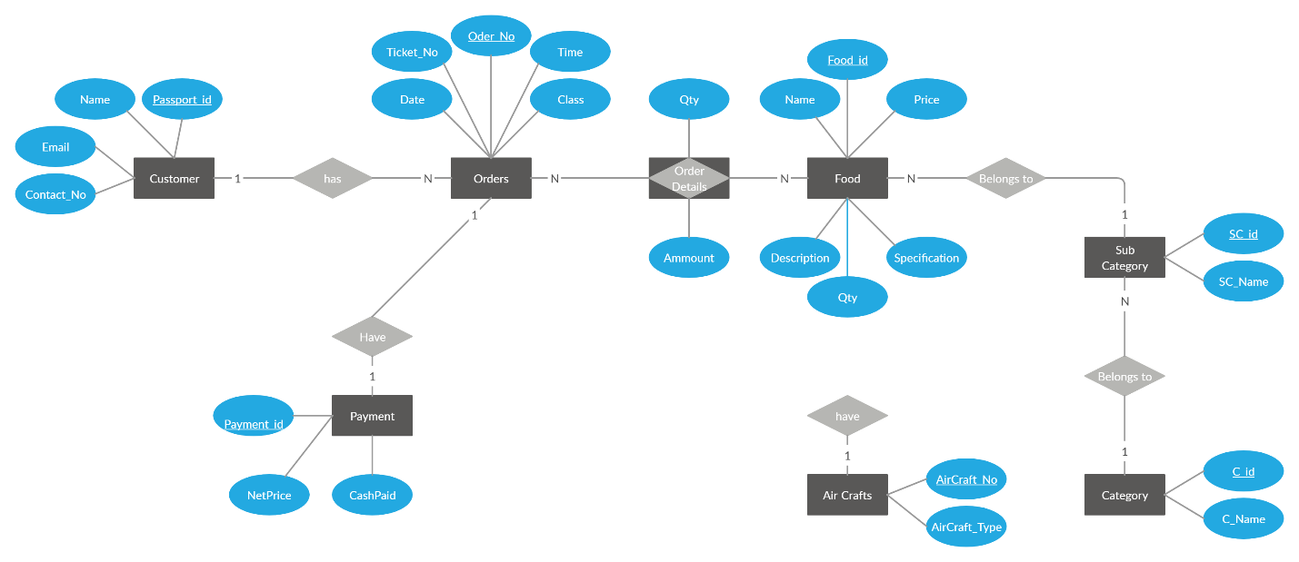

**Schema:**

**Database Design Features:**

* Products (Add, View, Update)
* Orders (Confirm, Cancel)
* Manage Users (Add, List, Update)
* Customer Profile
* Product Purchases by Supplier
* Purchase Orders
* Employees profile
* Customer (direct customer, wholesale customer)

**Diagram**

